MyTime is a simple clock application with a clock, timer, alarm, and stopwatch system. Here is use it, intensively.

**Clock:**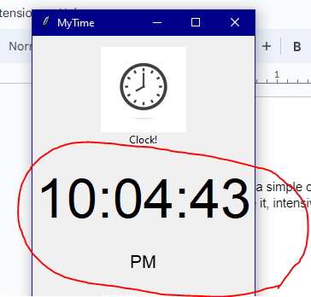

This is the main clock for the app it also has an AM/PM label, this is your current system time.

**Alarm:**

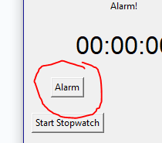To access the alarm creation screen press this button, located below the stopwatch label.

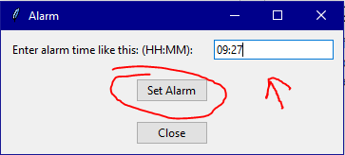  
  
This window will appear when you click the alarm button enter your alarm time in HH:MM format so this is how you would make an alarm for 9:27, then when your happy with your alarm time click Set Alarm.

**Stopwatch:**

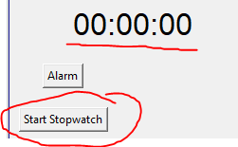

To start your stopwatch click the “Start Stopwatch” button then, the stopwatch at the top that is underlined will start counting, when you want to stop the alarm simply click the same button again, but now it will say “Stop Stopwatch” **Timer:**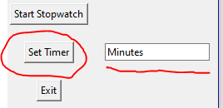  
  
To set a timer, first where it says “Minutes” enter a number for how longer the timer should be, for a 10 minute timer simply type “10” then click “Set Timer” The application will let you know when its done.